CSA0501-DATABASE MANAGEMENT SYSTEMS
LAB EXPERIMENTS DATE: 17-08-2026

EXPERIMENT 9 - Query with Joins – Equi Join, Inner Join, Outer Join

AIM:

To perform Equi Join, Inner Join, and Outer Join operations on the given relations using SQL.

PROCEDURE:

Create and use the required database.

Create the INTERN and DEPARTMENT tables.

Insert records into both tables.

Perform an Equi Join using the common department column.

Perform an Inner Join to display matching records from both tables.

Perform Left Outer Join to display all records from the left table.

Perform Right Outer Join to display all records from the right table.

Execute the queries and observe the results.

PROGRAM:

1. Equi Join
SELECT I.InternID,
I.InternName,
D.DeptNo,
D.DeptName
FROM INTERN_JOIN I, DEPARTMENT D
WHERE I.InternID = D.DeptNo;
OUTPUT:
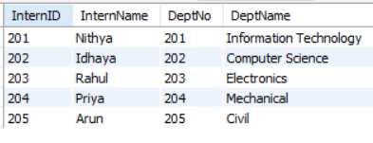

2. Inner Join
SELECT I.InternID,
I.InternName,
D.DeptNo,
D.DeptName
FROM INTERN_JOIN I
INNER JOIN DEPARTMENT D
ON I.InternID = D.DeptNo;
OUTPUT:
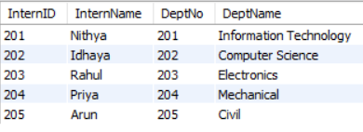

3. Left Outer Join
SELECT I.InternID,
I.InternName,
D.DeptNo,
D.DeptName
FROM INTERN_JOIN I
LEFT JOIN DEPARTMENT D
ON I.InternID = D.DeptNo;
OUTPUT:
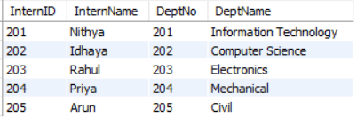

4. Right Outer Join
SELECT I.InternID,
I.InternName,
D.DeptNo,
D.DeptName
FROM INTERN_JOIN I
RIGHT JOIN DEPARTMENT D
ON I.InternID = D.DeptNo;
OUTPUT:
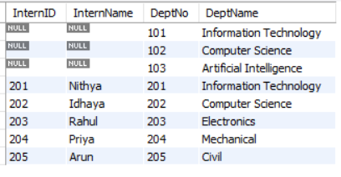

RESULT:

Thus, the Equi Join, Inner Join, Left Outer Join and Right Outer Join operations were successfully performed on the INTERN_JOIN and DEPARTMENT tables.

